
Eclipse Identity Recognition Corporation
1154 60th Street
Brooklyn, NY 11219

OnSSI & EclipseIR
Integration Plan

January 18, 2012
Version 1.00B

Copyright (c) 2012, Eclipse Identity Recognition Corporation (EclipseIR). All rights reserved worldwide. Eclipse Identity Recognition Corporation, EclipseIR, INDIface, and their respective logos are trademarks of Eclipse Identity Recognition Corporation. This document is a CONFIDENTIAL TRADE SECRET of Eclipse Identity Recognition Corporation; it may not be copied, reproduced, transmitted, or otherwise shared except under the terms of a non-disclosure or other agreement with EclipseIR.

Background
Eclipse Identity Recognition Corporation™ provides Personal Identity Recognition via its face-based analytics known as INDIface™. It is used to detect faces and facial features and then generate face templates for searching and matching. In addition, the INDIface analytics can also determine skin tone, upper and lower clothes color, and an estimated height of a person. The INDIbase system provides for the enrollment, storage, management, retrieval, and matching of INDIface templates. INDIbase will also manage facial and other images as well as personal identification and characteristic data.

On-Net Surveillance Systems, Inc. (OnSSI) is creating a new era in video surveillance in which intuitive software seamlessly connects and improves security processes and makes up for the limits of human capacity. This is driven by the modern world’s need for proactive, results oriented security solutions that can help to prevent incidents, instead of merely record them.

Intuitive, automated features of the software combine multiple alarms into meaningful alerts, which results in better security and less need for operators watching screens, and this in turn lowers operating costs. Built around user needs, the OnSSI system offers elegant simplicity and is easy to use. In addition, a full, instant view of security processes and relevant events increases productivity across enterprises.

OnSSI points the way to the future, with software designed to meet increasingly complex global security demands that go beyond traditional, hands on surveillance models.

In February 2010, OnSSI was selected at the top of the “The Top 10 Open Video Management Systems” by Security Magazine.

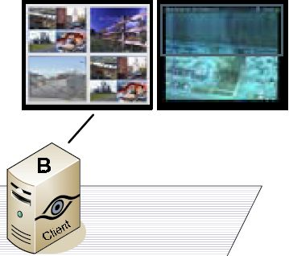
Ocularis, OnSSI's flagship IP-video and security platform, is a comprehensive video management system that combines powerful network video recorders (NVRs) with physical security information management (PSIM) functionality.

Ocularis represents the latest evolution in IP-video surveillance and security. As an integrated video and event management platform, it includes a full-fledged video management system (VMS) for streaming, recording and managing an unlimited number of cameras at multiple sites.

Ocularis' straightforward workflow provides a collaborative environment in which video and alerts from across the organization are converted into meaningful events, for efficient shared handling and building a video-evidence case file.

FusionIR™ packages EclipseIR's INDIface technologies into a software developer kit (SDK) to allow an original equipment manufacturer (OEM) to include the technologies in their existing systems or a third party developer to create custom applications with INDIface. EclipseIR's own applications (recapped in the table below) use the same SDK that is available to OEM customers.

MatchPointIRTM | SearchPointIRTM | ResolverIRTM
Monitor entrances and access points in commercial and public facilities | Search and monitor live and stored video for analysis and investigation | A video forensics tool to locate individuals based on biometric characteristics
Detects faces at an entrance or "choke-point,” and identifies individuals by matching detected faces to a person of interest database. Alarms can be set to notify of known troublemakers, intruders, and VIPs. | Searches stored video files to detect and locate specific persons of interest. Ideal in video investigations for locating lost persons, troublemakers, or a known predator. | Incorporating multi-modal techniques, Resolver utilizes advanced biometric video analytics to search for persons of interest based not only on the facial recognition but also on skin color, height, upper & lower body clothing color.
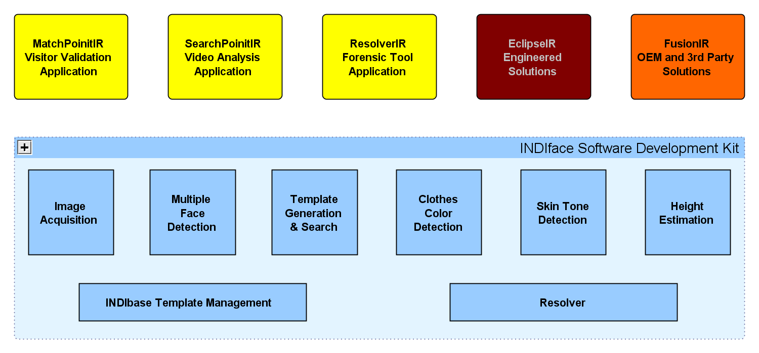

Introduction

This document will describe phases of integration between EclipseIR's applications and FusionIR SDK and OnSSI's SDK to allow OnSSI's users the ability to use INDIface facial recognition and analytics. During Phase One, the operator will be required to initate facial recognition from EclipseIR's application, selecting from the available live cameras registered in the Ocularis system. During this phase, alerts will initially appear in EclipseIR's application and will later be forwarded to Ocularis. In Phase Two, operators will be able to select up to four channels of stored video on the Ocularis-managed NVRs. In Phase Three, we will further integrate the EclipseIR user interface into the Ocularis user interface so that operators do not have to switch between systems to initiate facial recognition and analytics. The ultimate integration would come in Phase Four where we envision adding “Who is This?” “Where has this person been seen?” “Where are these Key People Now?” and “Who does this Person Associate With?” buttons directly into the Occularis user interface. The first three phases can be accomplished with EclipseIR's current and future applications and FusionIR generations with the support of OnSSI's technical team. The fourth phase will require some effort from OnSSI to fully integrate INDIface into Ocularis.

Comparison

Capability by Phase | 1A | 1B | 1C | 1D | 2 | 3 | 4
Enumerate video sources from Ocularis system | ☑ | ☑ | ☑ | ☑ | ☑ | ☑
Initiate facial recognition from EclipseIR application | ☑ | ☑ | ☑ |  | TBD
Initiate facial recognition from Ocularis monitor |  |  |  | ☑ | TBD | ☑ | ☑
Report alert in EclipseIR application | ☑
Report alert to Ocularis system |  | ☑
Report alert to Ocularis system with supporting data space (bookmark) |  |  | ☑ | ☑ | ☑ | ☑
Review alert in EclipseIR application | ☑ | ☑ | ☑ |  | TBD
Review alert on Ocularis monitor |  |  |  | ☑ | TBD | ☑ | ☑
Channels of live video | One | One | One | One
Channels of stored or live video |  |  |  |  | Four | Four | As necc.
“Alert me if this person approaches this camera again.” | ☑ | ☑ | ☑ | ☑
“Who is This?” |  |  |  |  | ☑ | ☑ | ✓!
“Where has this person been seen?” |  |  |  |  | ☑ | ☑ | ✓!
“Where are these Key People Now?” |  |  |  |  | ☑ | ☑ | ✓!
“Who does this Person Associate With?” |  |  |  |  |  | ☑ | ✓!
Enrolled faces | 5 | 5 | 5 | 5 | 50000 | Mil. | MMil.
Timeframe | 1Q12 | 1Q12 | 1Q12 | 1Q12 | 2Q12 | 4Q12 | TBD

Phase One

In this phase, Eclipse IR's applications would retrieve available video sources from the Ocularis system and present them to operators of the eclipse IR application. For the short term, the INDIface SDK will connect to those live cameras directly with a user mode ONVIF connection.
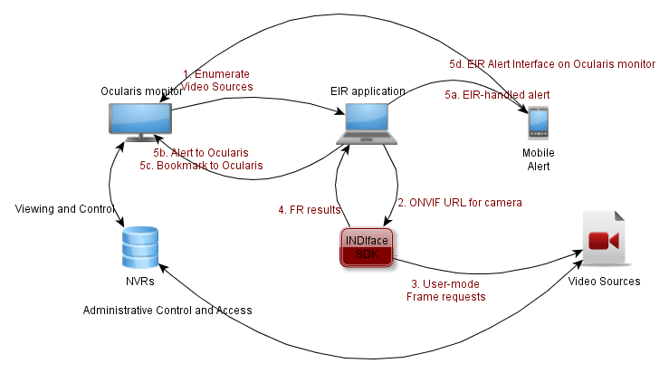
In the first release, alerts would be handled completely within the EIR alert system (Phase 1A). Later, the EIR application would establish a socket connection to Ocularis to notify the operator of a facial recognition alert (Phase 1B) or submit a bookmark to Ocularis which would mark a section of the video that generated the alert and could include the enrolled images associated with the alert (Phase 1C). Note that during these alerts to Ocularis the operator would still be required to research and handle the alerts on a separate EclipseIR application. Finally, for this phase, we would like to find a way to replicate EclipseIR's application display using an HTML window on the Ocularis monitor (Phase 1D).

Phase Two

This phase would focus on integration between the OnSSI SDK and EclipseIR's SDK to allow facial recognition images to be drawn from Ocularis managed video sources and network video recorders. This would be accomplished as part of EclipseIR's planned restructuring of controlling video sources with plug-in DLLs.
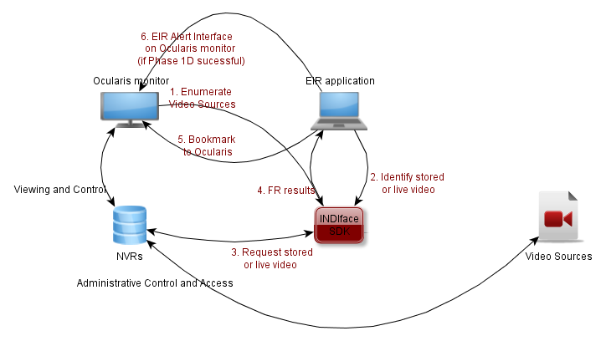

Phase Three

This phase would include building an HTML-based interface to the second generation INDIface technology servers that would live in Windows on the Ocularis monitor. This would presumably utilize an AJAX-type interface to manage requests and results while appearing to be responsive to the operator.

Phase Four

This phase would bring complete integration of EclipseIR's face recognition and personal characteristics technologies into OnSSI's Ocularis platform by integrating directly into the Ocularis user interface.

The ability to initiate facial recognition from the Ocularis user interface and to review generated alerts on an Ocularis monitor will depend upon the success of Phase 1D.
Fully integrated capability in the Ocularis user interface.
It would be nice to introduce what appears to be an integrated product at ISC West in Las Vegas March 28, 2012.

